# In-Class Lab 3

1. Create Windows event using PowerShell (**I have used “3908” instead of “1229_3908” as the underscore was unable to convert value "1229_3908" to type "System.Int32".**) 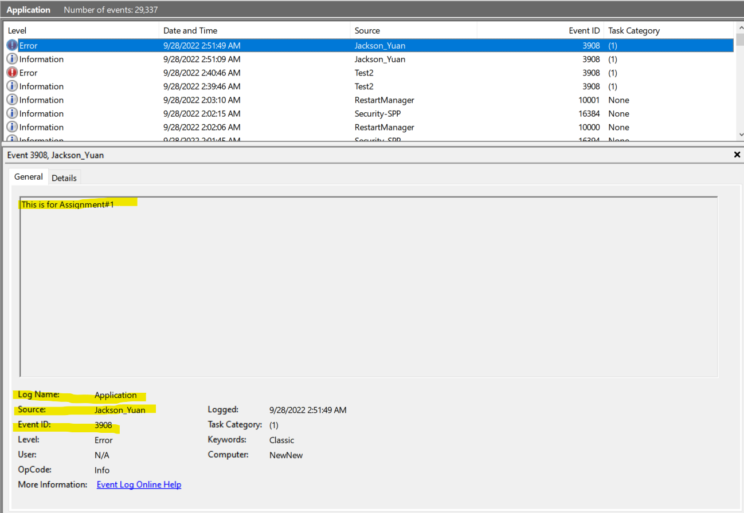
2. Setting up the forwarder index for splunk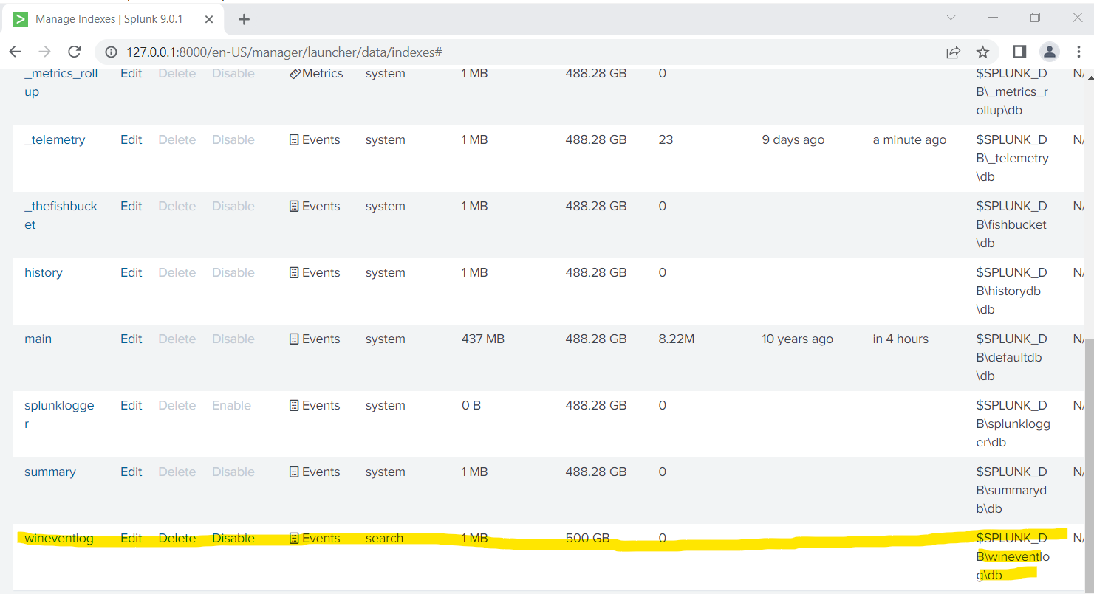
3. Configure settings for receiving port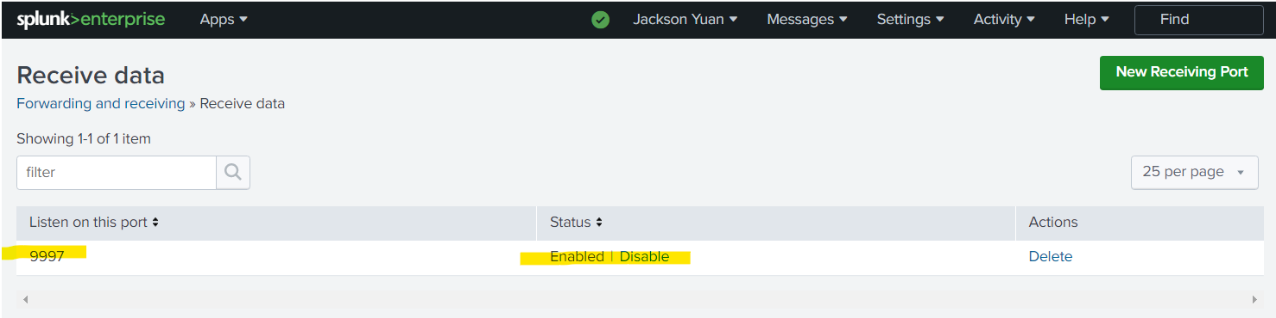
4. Installing splunk universal forwarder on host machine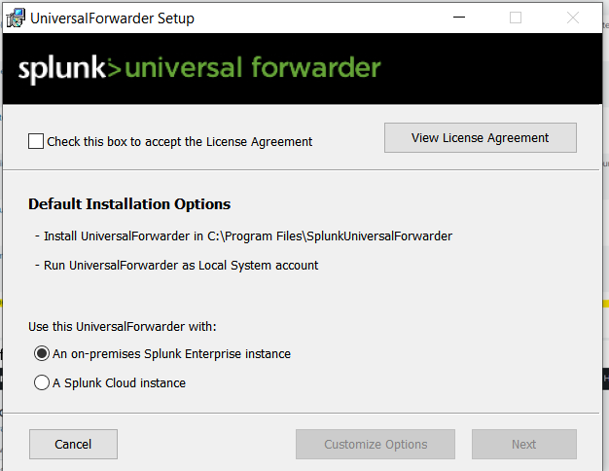
5. Searching for host windows event created in Lab #3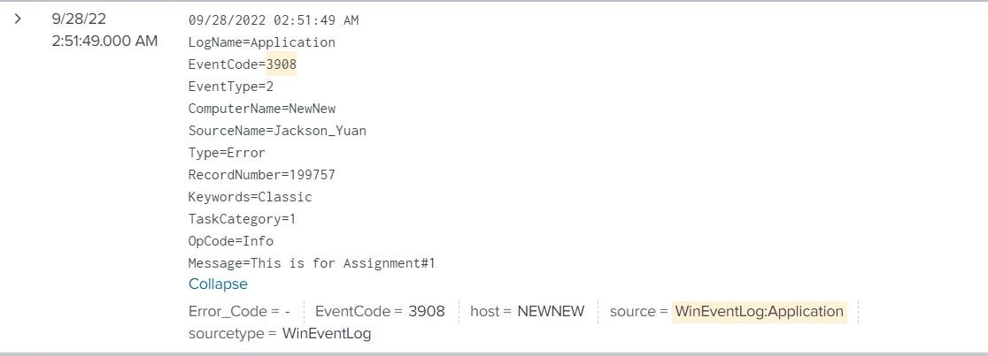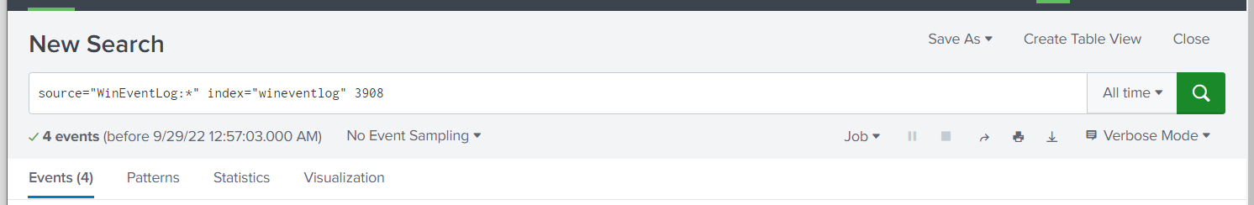

# In-Class Lab 4

1. Search query to forward to Splunk information about installed patches for your second host computer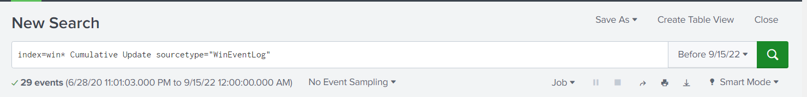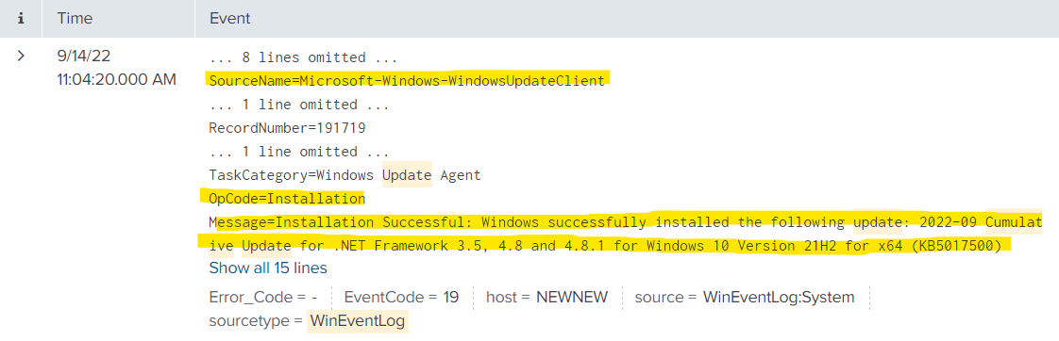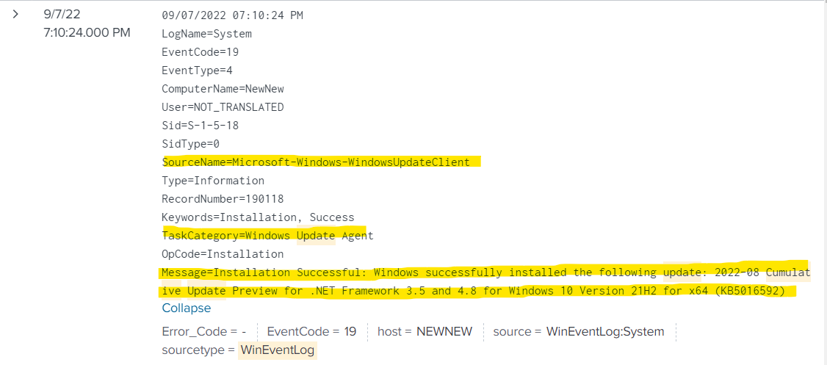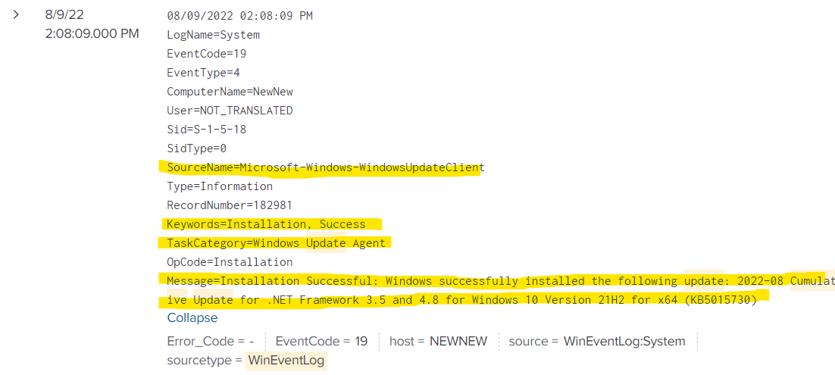
2. Checking for available patches for my host machine. This yielded no results as my host computer is currently up to date with the latest patches.